# **Document - changes on university page**

Sabhi ke sath ek heading jayegi paragraph niche jayega

# **.1—ek about section banega jisme university ke bare me hoga** Ek heading jayegi

Ek paragrapgh jayega

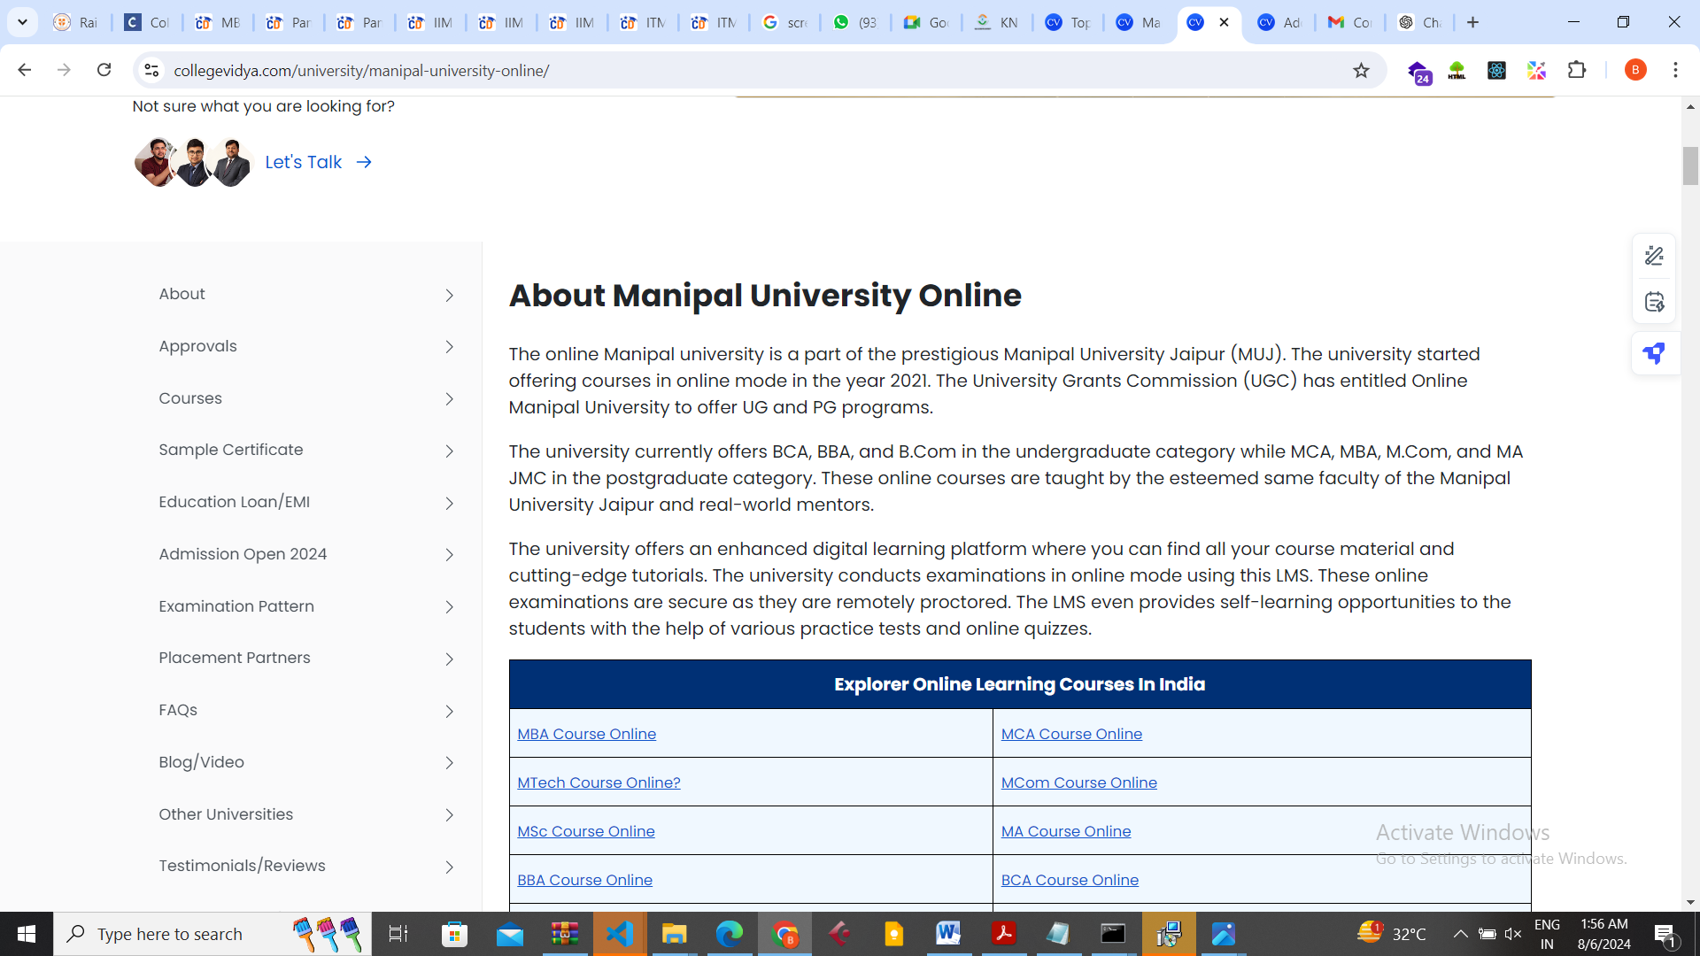

Ek – more about online fact krke heading aur niche paragraph jayega –

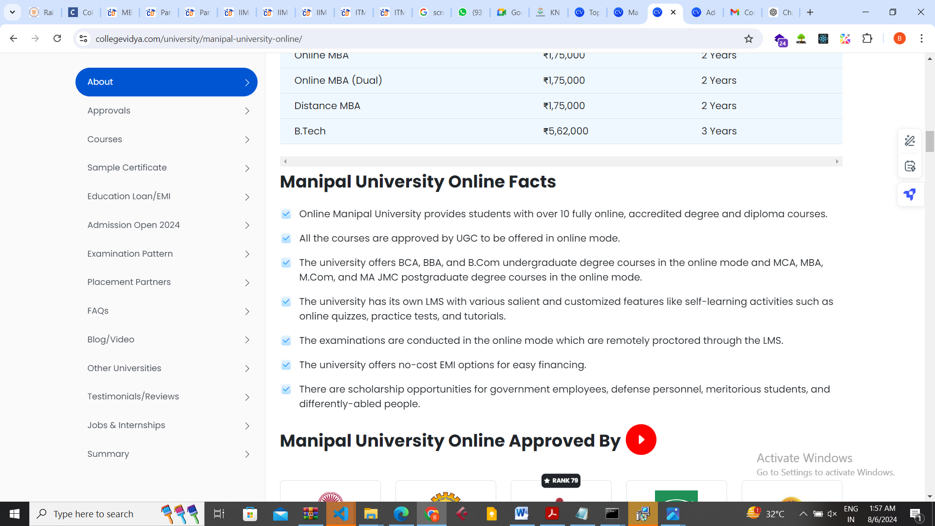

# **Online review sction banega ek – jiski ek rating fix hogi uske bad jo student review krenge usk according uski rating bhdti jayegi**

Check website link for compare-

https://collegevidya.com/university/manipal-university-online/

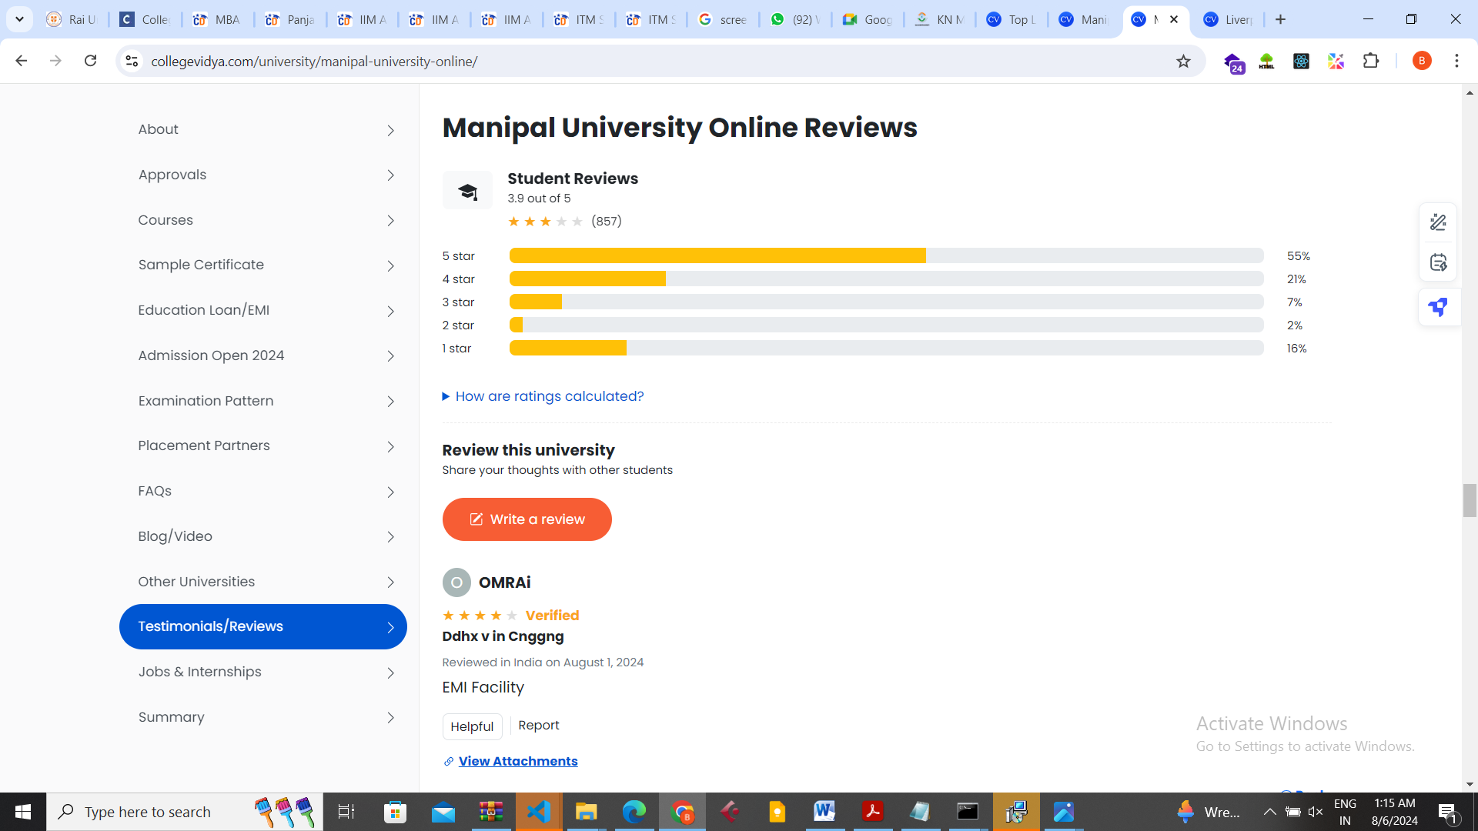

Placement section –

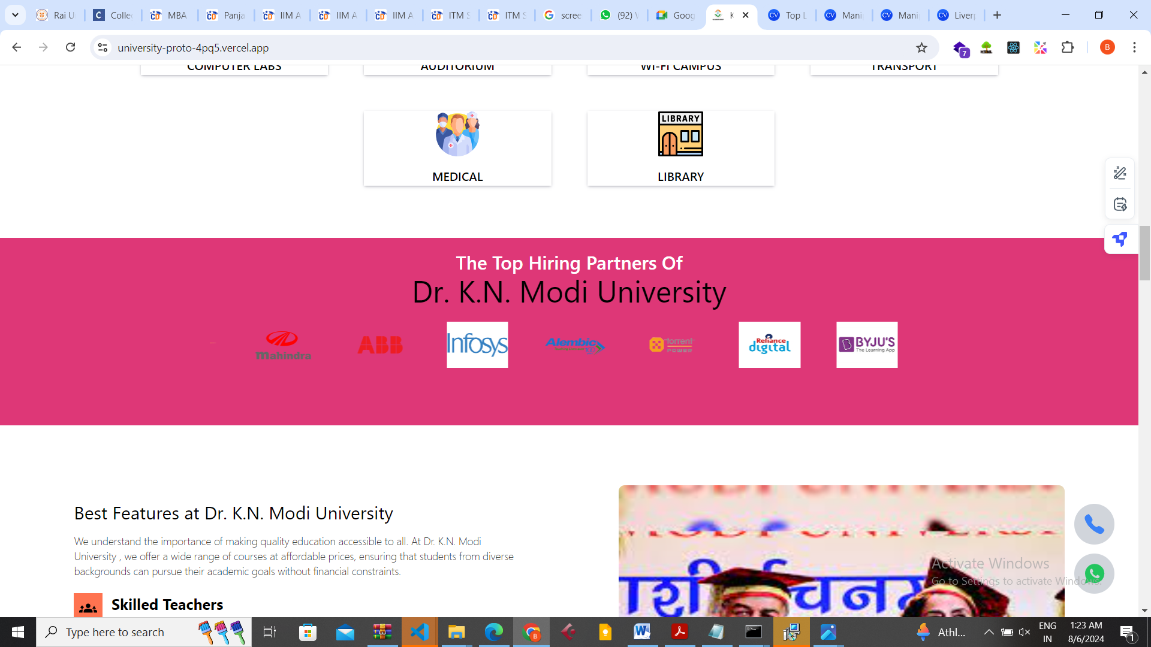

is section me paragraph add krna hain ye jo hiring patner se up aayega

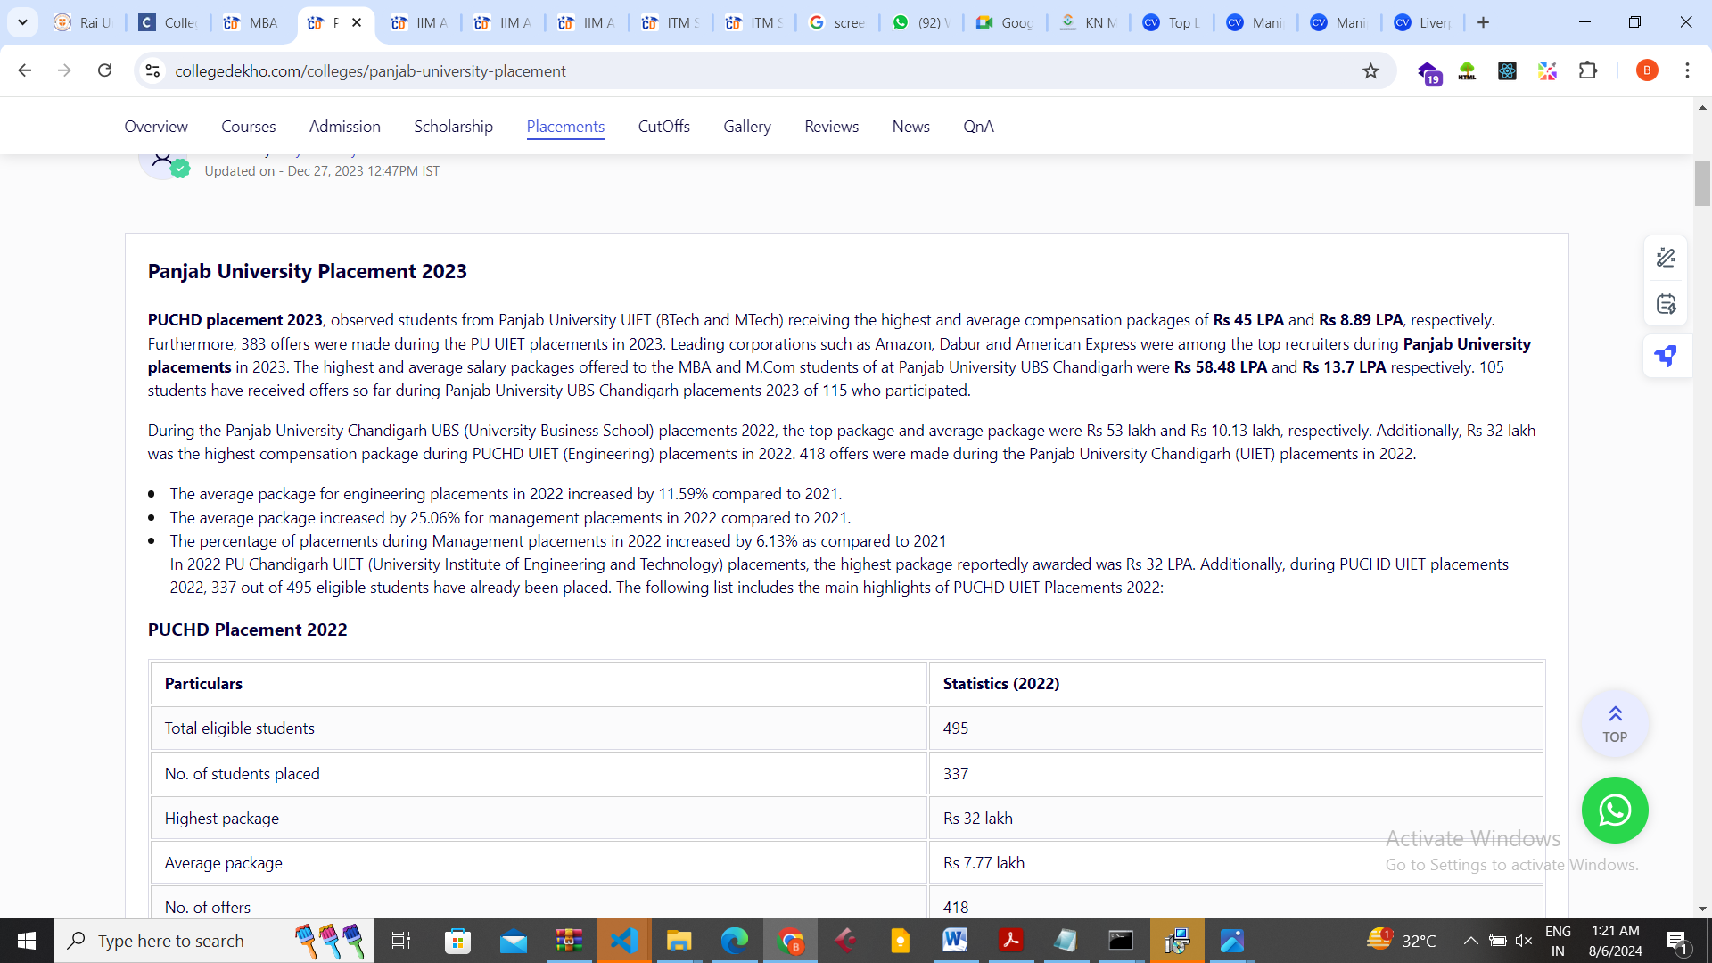

Ek university consider section banega – according to rating or course or place k accrding

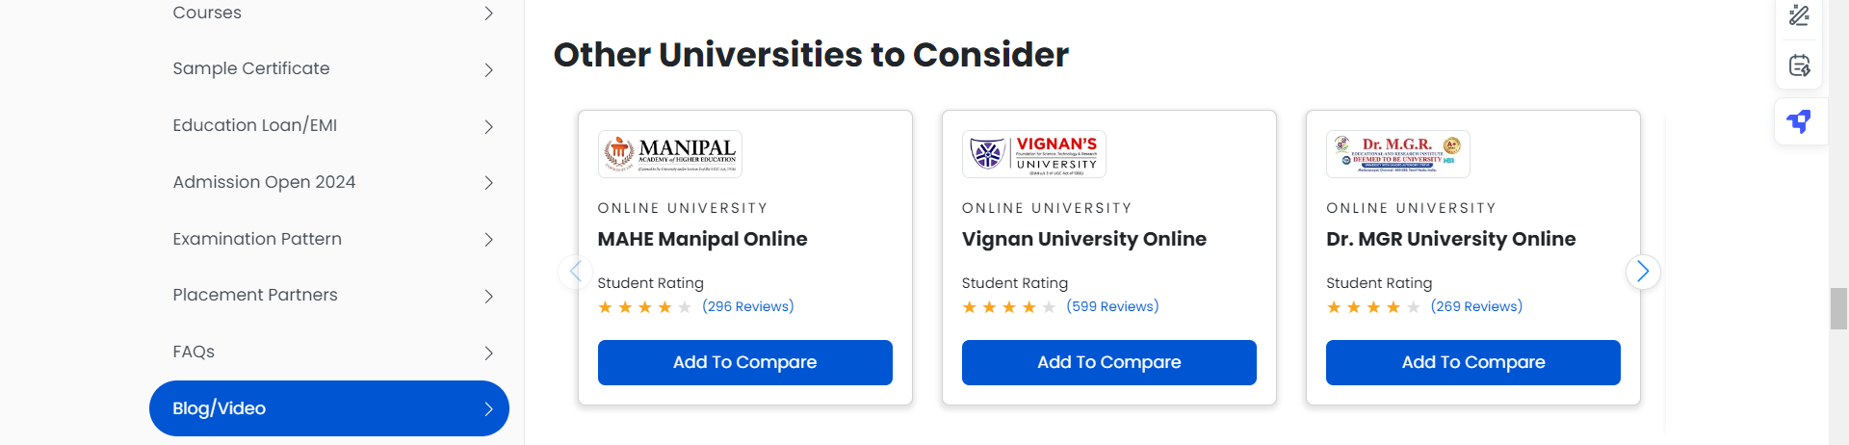

3 image banner ke liye image dalne k option honge taki admin har 10 din me vo alg dal sake --

Ek section banega placed students ka sb universities k alg alg placed bacche honge –

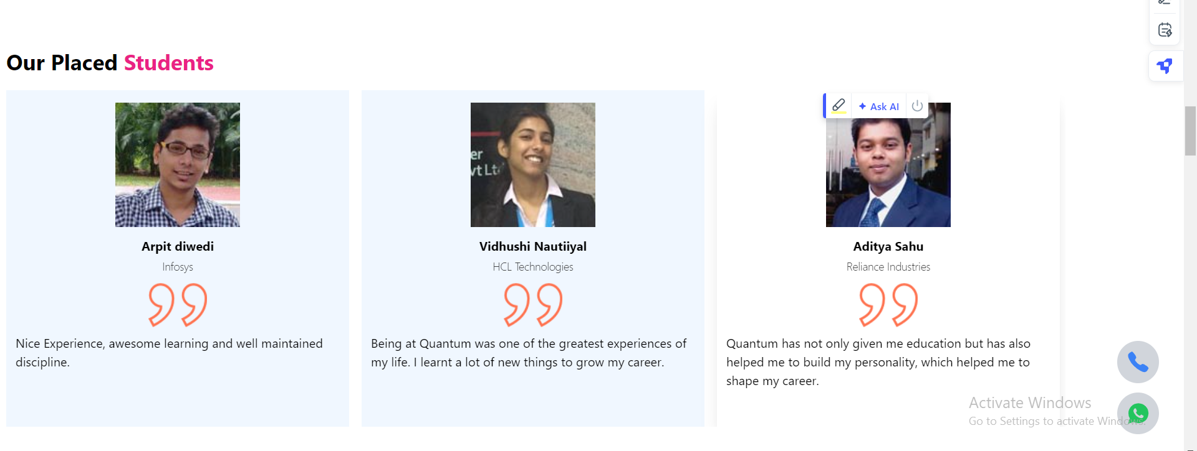

Ek student story section jisme vo youtube video dal sake

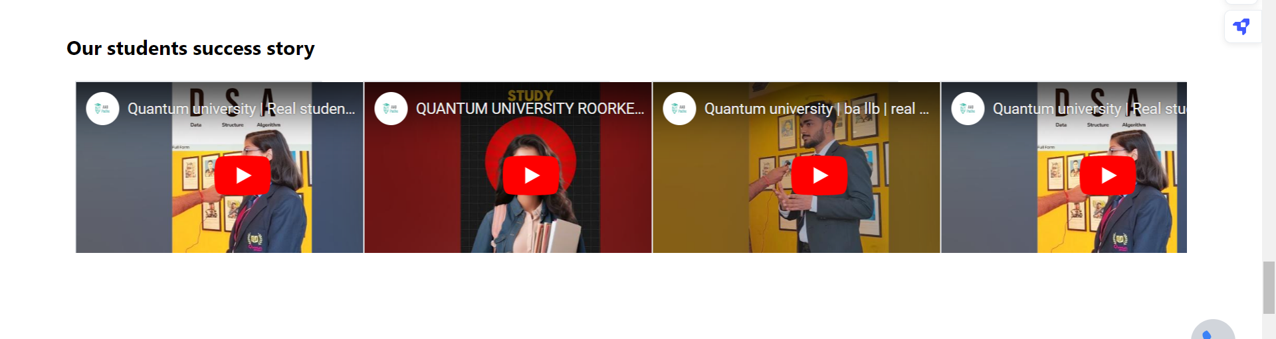

Fees structure ke liye –jisme sare course ki fees show kar paye –as like this --

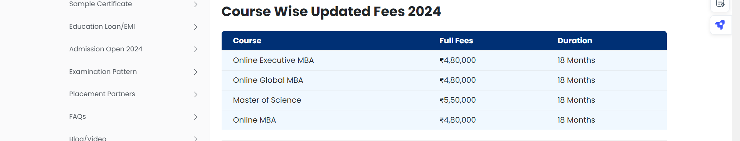

Ek section banega – gallery section bana dena jisme university ki sari image dal sake

Ek section university professor ka bna dena jisme –

Profeesor ka nam – sb k sath paragraph ka jarur rkhna kyuki kuch bhi extra information ho hum usme dedenge

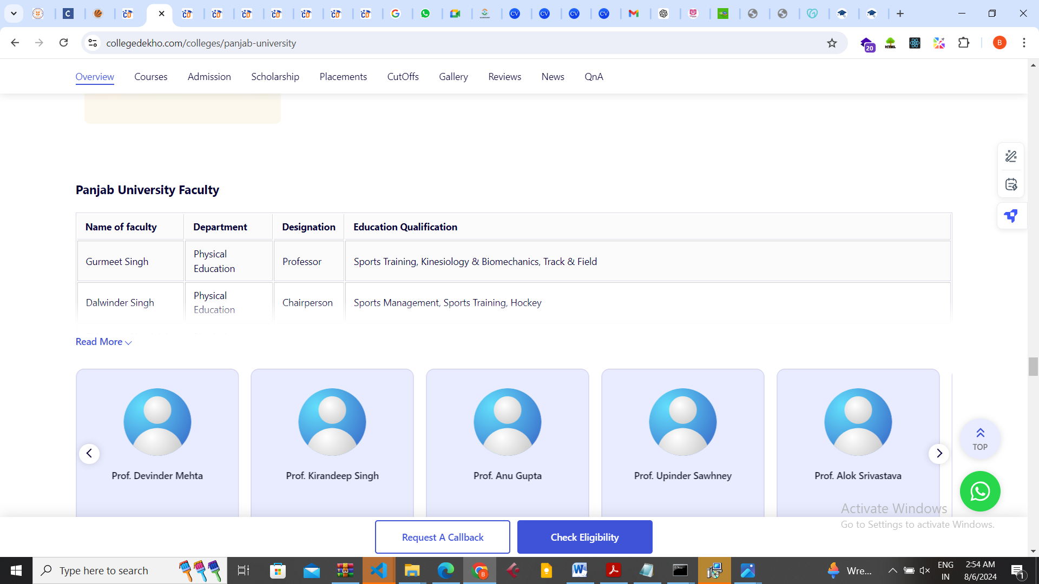

Ek talk to agent me har university ka alg takh to agent hoga to number sbke alg honge --- ek button hoga jisme likha hoga – if you confuse talk to agent to sb university k alg agent honge

Ugc / aicte approved k liye data likh lena taki unko alg alg div me lekr slide krva ske